Customer Segmentation
Level 1: Basic Filtering
- Show all customers from Bangalore 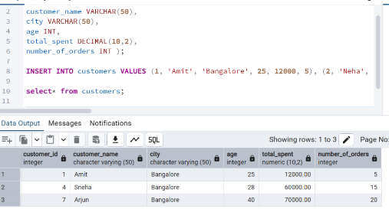

- Display customers with total_spent > 20000 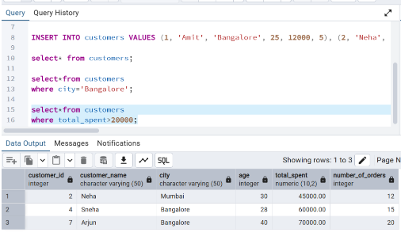

- List customers aged between 25 and 35 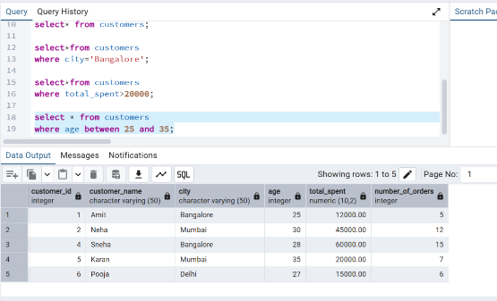

Level 2: Sorting & Aggregation
- Show all customers sorted by total_spent (highest first) 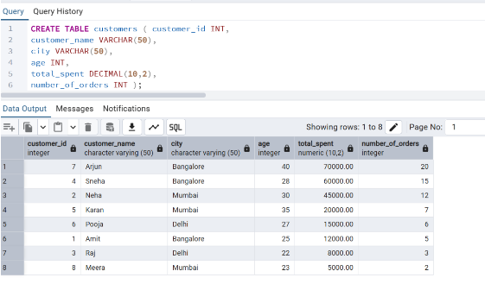

- Find the total revenue generated 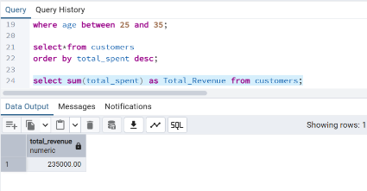

- Find the average spending per customer 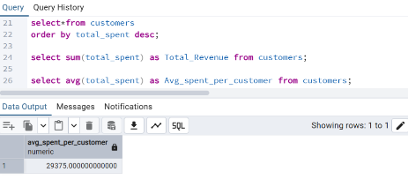

Level 3: Grouping
- Find total spending per city 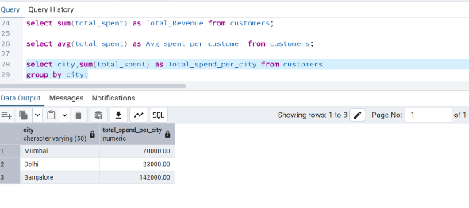

- Count number of customers in each city 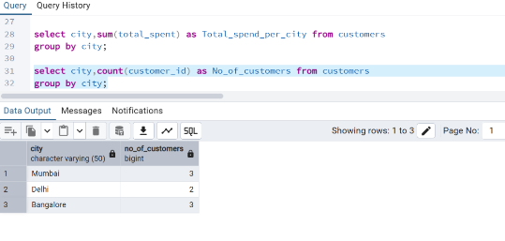

Level 4: Customer Segmentation (CORE TASK )
9.Count how many customers fall into each segment 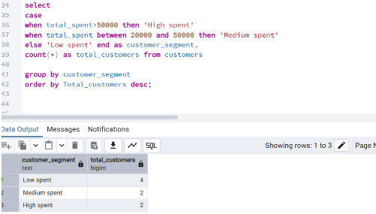
Level 5: Advanced Basic (HAVING)
10.Show cities where total spending is greater than 50000
